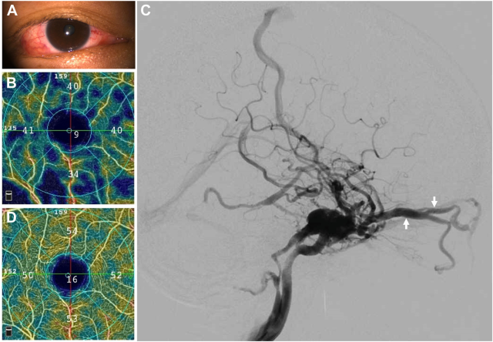

A 44-year-old woman presented with redness in the right eye for 4 weeks (A). Her visual acuity was 20/20 in both eyes. Intraocularpressure was 27/17 mmHg in the right and left eye, respectively. Incomitant esotropia attributed to right abducens palsy was also noted. Herfundus was normal, but a marked superficial vascular complex (SVC) dropout was found on OCT angiography (B). Digital subtractionangiography (C) revealed a right direct carotid-cavernous fistula (CCF) with venous drainage to the right inferior petrosal sinus, bilateralophthalmic veins (C, arrow), and cortical veins. The reduction of SVC reversed (D), with improvement of ocular hypertension and esotropia2 weeks after embolization of right CCF. Based on the provided images and clinical description please make an ophthalmic diagnosis for this patient. And output the diagnostic conclusions only

**Right direct carotid-cavernous fistula**